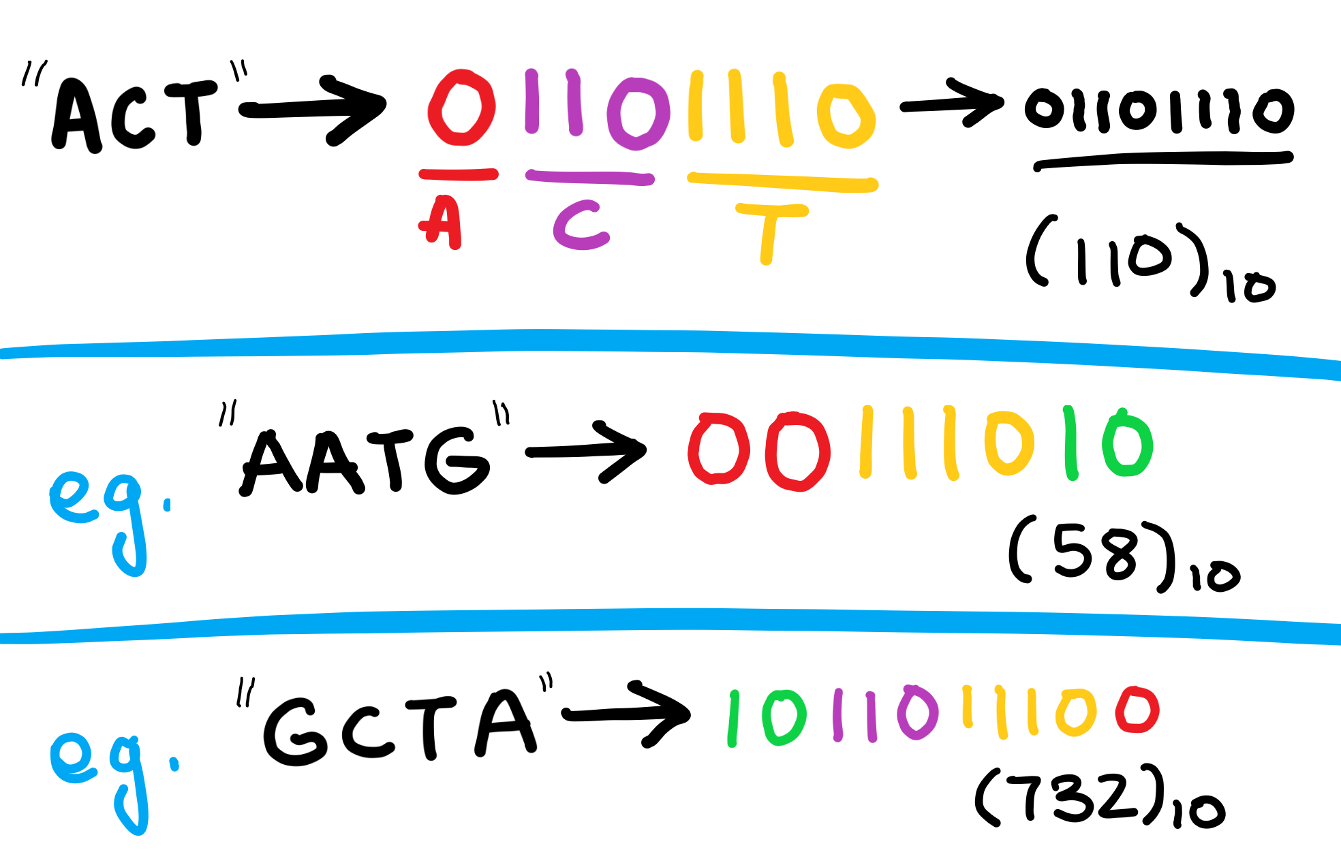
It banks on the basic idea of representing the most common recurring subunit with the least number of bits. A lot of the time, this recurring subunit may be a character, like we are assuming in this article.
It’s a widely used technique, and some places where it’s used are JPEG images, MP3 files and the compression of DNA sequences.

This algorithm exploits the use of recurring characters to our advantage. We try to represent these recurring characters using fewer bits than they would normally take. For example, let’s assume we have a large text file containing 1000 occurrences of ‘A’, and only ~200 occurrences of the other alphabets.
Normally, each letter would take up 8 bits of data (1 Byte). This would mean the total size of data would be 8*number of characters. (in bits)
But if there were some way, in which we could try to represent ‘A’ in a way that took lesser than 8 bits, say 2 bits, we would be reducing our size (ideally) by 1000*(8–2) = 6000 bits.
For larger file sizes, this would be a significant change. One more thing we should keep in mind is that ‘A’ wouldn’t be the only letter that would be represented in lesser than 8 bits. For example, we may have a situation where with ‘A’, we may represent ‘C’ and ‘D’ with 3 bits each.

For example, let’s say we want to compress a DNA sequence, we have a text file containing the string “AGGACTAAAAACG”
The distribution of each letter stands at -
‘A’ : 7
‘G’ : 3
‘C’ : 2
‘T’ : 1

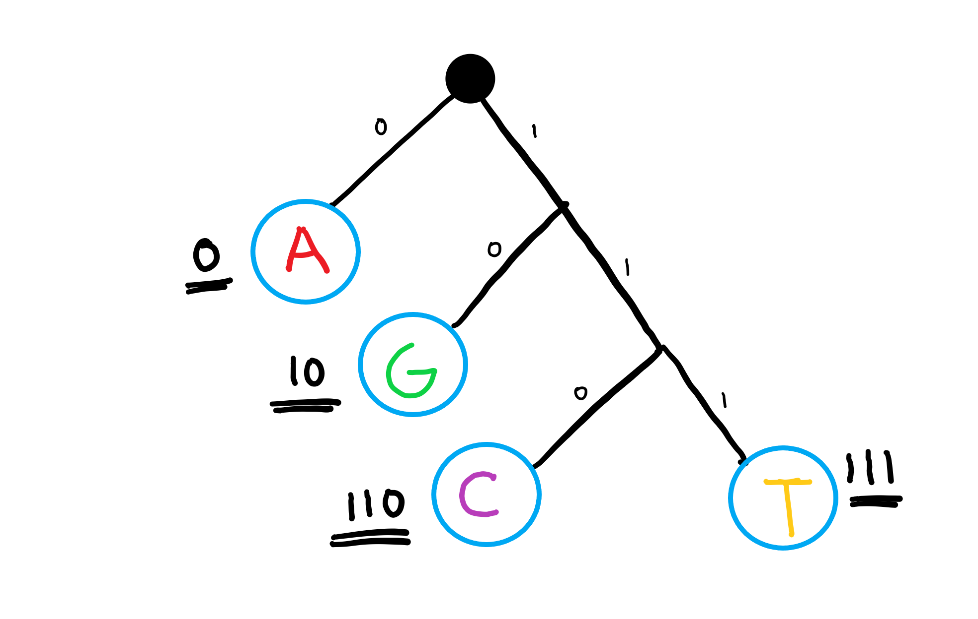
Our Huffman tree would look something like this -

Normally we would represent ‘A’ ‘G’, ‘T’ and ‘C’ with 8 bits each. But now the new representations are -
A: 0 (1 bit)
G: 10 (2 bits)
C: 110 (3 bits)
T : 111 (3 bits)
So something like ‘ACT’ would be represented as 0110111.
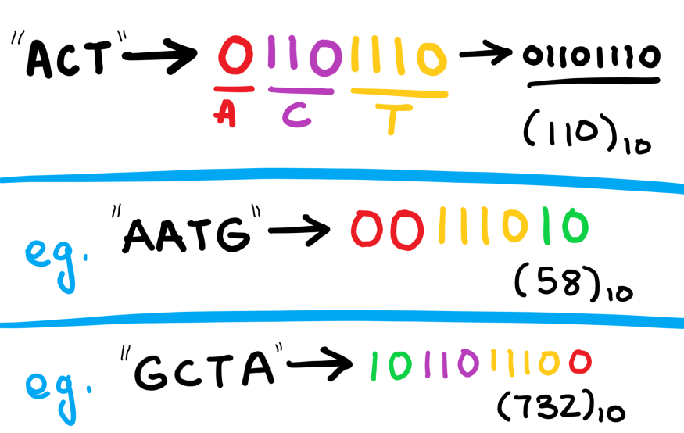

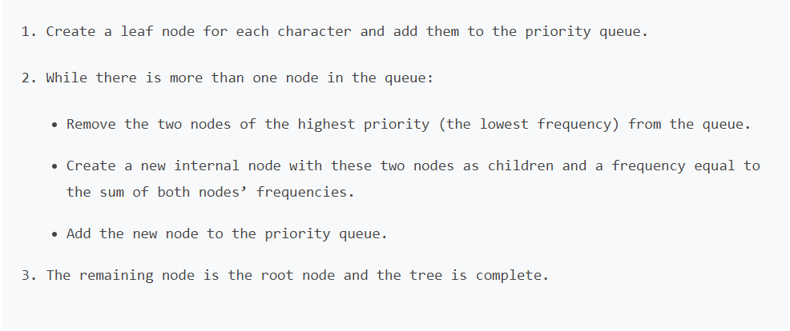
Algorithm for creating the Huffman Tree-
Step 1- Create a leaf node for each character and build a min heap using all the nodes (The frequency value is used to compare two nodes in min heap)
Step 2- Repeat Steps 3 to 5 while heap has more than one node
Step 3- Extract two nodes, say x and y, with minimum frequency from the heap
Step 4- Create a new internal node z with x as its left child and y as its right child.
Also frequency(z)= frequency(x)+frequency(y)
Step 5- Add z to min heap
Step 6- Last node in the heap is the root of Huffman tree
Let’s try and create Huffman Tree for the following characters along with their frequencies using the above algorithm-

Characters | Frequencies
a | 10
e | 15
i | 12
o | 3
u | 4
s | 13
t | 1
Step A- Create leaf nodes for all the characters and add them to the min heap.
- Step 1- Create a leaf node for each character and build a min heap using all the nodes (The frequency value is used to compare two nodes in min heap)
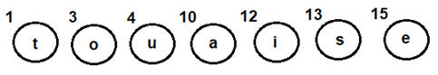
Step B- Repeat the following steps till heap has more than one nodes
- Step 3- Extract two nodes, say x and y, with minimum frequency from the heap
- Step 4- Create a new internal node z with x as its left child and y as its right child. Also frequency(z)= frequency(x)+frequency(y)
- Step 5- Add z to min heap
- Extract and Combinenode u with an internal node having 4 as the frequency
- Add the new internal node to priority queue-
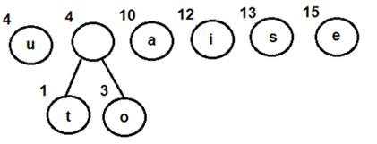
- Extract and Combine node awith an internal node having 8 as the frequency
- Add the new internal node to priority queue-
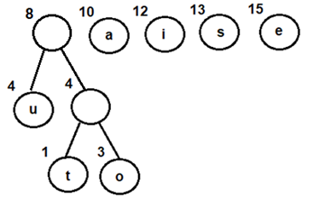

- Extract and Combine nodes i and s
- Add the new internal node to priority queue-
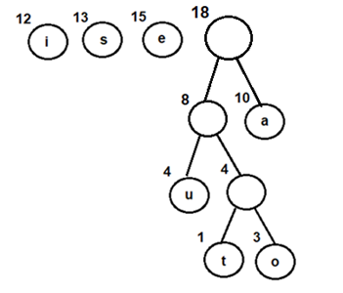
- Extract and Combine nodes i and s
- Add the new internal node to priority queue-
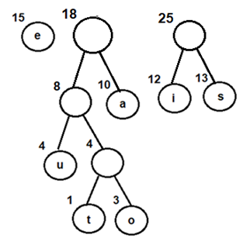
- Extract and Combine node ewith an internal node having 18 as the frequency
- Add the new internal node to priority queue-
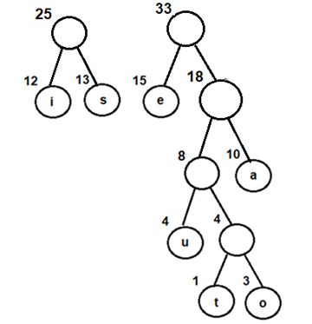
- Finally, Extract and Combine internal nodes having 25 and 33 as the frequency
- Add the new internal node to priority queue-
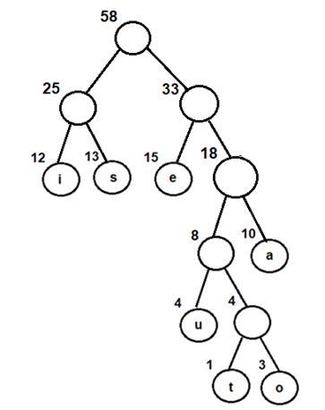
Now, since we have only one node in the queue, the control will exit out of the loop
Step C- Since internal node with frequency 58 is the only node in the queue, it becomes the root of Huffman tree.
Step 6- Last node in the heap is the root of Huffman tree

